Highly-Available Distributed In-Memory Cache with Byzantine Paxos

Dalei Yang
4 May 2016
Abstract
I present the high level design for a distributed in-memory cache. The consensus algorithm based on state machine replication and tolerate Byzantine faults by having 2f +1 nonfaulty processes emulate the ordinary Paxos algorithm despite the presence of f malicious processes [9]. Fault-tolerate log is replicated to all replicas and applied to in-memory cache which is implemented with lock-free technique. Lock-free design provides the highest throughput under multithreading and competing circumstances. I exposed in-memory cache API to external access through web interface. I choice Nginx to setup web interface which helps to achieve the maximum throughput of network environment.
Contents
Achieve consistence in a distributed system 1
Background knowledge 1
The capability for this consensus algorithm 1
System Architecture 2
Normal case operation 2
New leader election 3
Other implementation techniques 3
High-Performance In-Memory cache 3
High-Performance API service 4
References 4

Achieve consistence in a distributed system

Background knowledge
For Byzantine Paxos, refer to [9], [2].
For formal algorithm correctness prove, refer to [10], [11].
From engineering implementation perspective, refer to [1].

The capability for this consensus algorithm
- Guarantee data consistency among all replicas when facing benign faults and malicious faults.
  - Benign faults including service node unexpected stop, replicate message missing/re-transmit/re-order.
  - Malicious faults including faked replicate message, operator mistakes, and unexpected software errors.
- Guarantee algorithm is making progress in a good network environment and service node are healthy.

System Architecture

One replica
There is internal component for one replica.
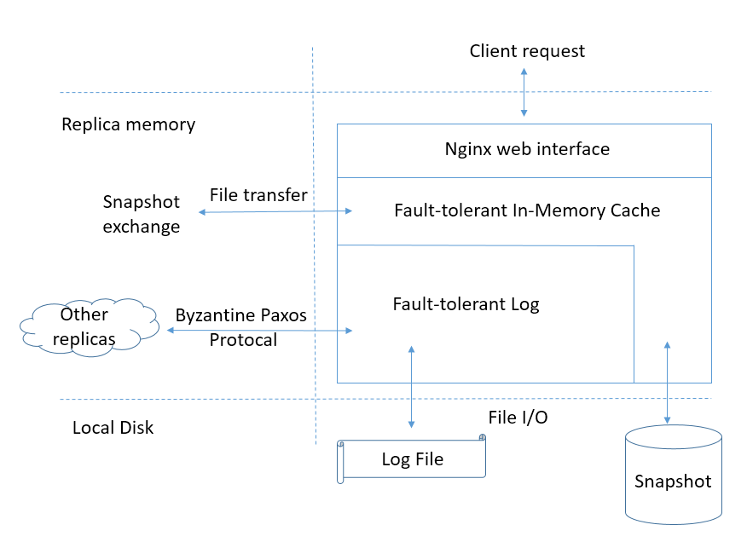

Distributed system
For example, four replicas are deployed into four datacenters.
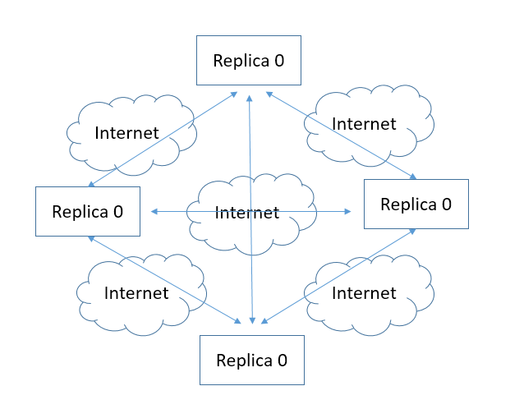

Normal case operation
Formal explanation of following figure, refer to [9], from section 2 to section 7.
3N+1 nodes with one node failed. N = 1.
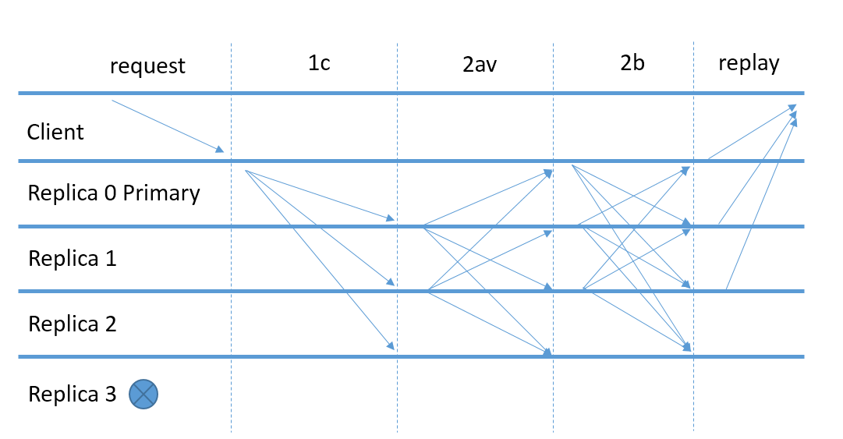

New leader election
Formal explanation of following figure, refer to [9], from section 2 to section 7.
Old leader failed and new leader is elected.
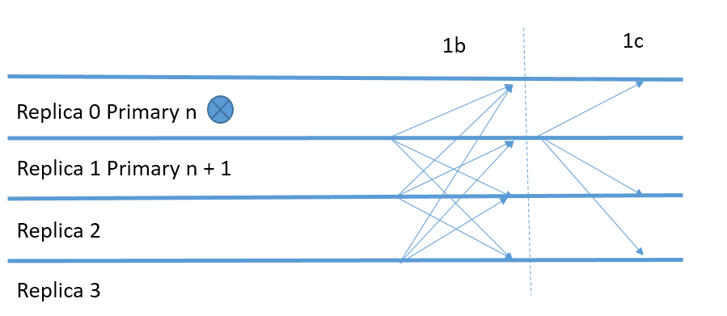

Other implementation techniques
- Uses the digests to check the correctness of the result.
- Symmetric cryptography to authenticate messages.
- Read-only operations optimization.
- Process requests in batches.
- Group membership reconfiguration.
- Handling node failure or disk corruption.
- Snapshots taken and log garbage collection.
- Runtime consistency checking.
- Defenses against denial-of-service attacks.

High-Performance In-Memory cache
In-Memory cache is implemented with lock-free technique and hosted in a daemon process.
There is its capability, when key is a Int64 integer and value is 256 bytes, tested on a DELL Z440 work station with 16 GB memory and 8 core CPU:
- Load 3,000,000 key value pairs one by one into memory in 4 seconds.
- Process 7,113,400 random get requests / 8,927,000 random update requests / 13,566,040 random delete requests in 1 second simultaneously.
- Its capability should be able to increases in a linear manner along with CPU core quantity increasing

High-Performance API service
Based on VOD web site experience, Nginx could provide 37G peak flow in one box with 4 gigabits network adapters. Nginx is a good choice to setup API server. It is hosted on the same box with in memory cache and communicate with each other through socket.

References
[1] Tushar, Robert and Joshua. Paxos Made Live - An Engineering Perspective. Proceedings of the 26th Annual ACM Symposium on Principles of Distributed Computing, ACM press (2007).
[2] Lamport, L. The part-time parliament. ACM Transactions on Computer Systems 16, 2 (1998), 133–169.
[3] Prisco, R. D., Lampson, B. W., and Lynch, N. A. Revisiting the paxos algorithm. In 11th International
Workshop on Distributed Algorithms (WDAG 96) (1997), pp. 111–125.
[4] Lamport, L. Paxos made simple. ACM SIGACT News 32, 4 (Dec. 2001), 18–25.
[5] Leslie Lamport. Specifying Systems. Addison-Wesley, Boston, 2003.
[6] Leslie Lamport. Cheap Paxos (with Mike Massa) Proceedings of the International Conference on Dependable Systems and Networks (DSN 2004) held in Florence in June-July 2004.
[7] Leslie Lamport. Fast paxos. Distributed Computing, 19(2):79-103, October 2006.
[8] Lamport, Shostak, and Pease. The byzantine generals problem. In Advances in Ultra-Dependable Distributed Systems, N. Suri, C. J. Walter, and M. M. Hugue (Eds.), IEEE Computer Society Press. 1995.
[9] Leslie Lamport. Byzantizing Paxos by Refinement, Distributed Computing: 25th International Symposium: DISC 2011, David Peleg, editor. Springer-Verlag (2011) 211-224.
[10] Leslie Lamport. The PlusCal Code for Byzantizing Paxos by Refinement. 2011.
[11] Leslie Lamport. Mechanically Checked Safety Proof of a Byzantine Paxos Algorithm
[12] Barbara Liskov and James Cowling. Viewstamped Replication Revisited. MIT technical report MIT-CSAIL-TR-2012-021, July 2012.

